**CHAPTER 3**

**PROPOSED METHODOLOGY**

**3.1 INTRODUCTION**

The proposed antenna is realized on Copper with PCB substrate with length=50mm, breath= 50mm and thickness h=2mm. The antenna is simulated using CST software. Microstrip patch antennas are fed by a variety of methods. This antenna is designed by using co-axial line feed as it is easier to fabricate.

**3.2 SIMULATION SOFTWARE – CST**

CST Microwave Studio is a specialist tool for the 3D EM simulation of high frequency components. The unparalleled performance from CST makes it the first choice in leading R&D departments, since it enables the fast and accurate analysis of high frequency (HF) devices such as antennas, filters, couplers, planar and multi-layer structures and SI and MWS quickly gives insight into the EM behavior of your high frequency designs.

**3.2.1 CST SOFTWARE DESCRIPTION:**

The antenna is designed and simulated in CST (Computer simulation technology) design software. CST is a commercial finite element method solver for electromagnetic structures. The acronym originally stood for high frequency structural simulator. It is one of several commercial tools used for antenna design, and the design of complex RF electronic circuit elements including filters, transmission lines, and packaging. CST offers accurate, efficient computational solutions for electromagnetic design and analysis. Our 3D EM simulation software is user friendly and enables you to choose the most appropriate method for the design and optimization of devices operating in a wide range of frequencies. It is based on Finite Element Method (FEM).

FEM has its origin in the field of structural analysis. It is a more powerful and adaptable numerical technique for handling programs involving complex 24 geometries. In mathematics, FEM is a numerical technique for finding approximate solutions to boundary value problems. It uses variation methods (the Calculus of variations) to decrease an error function and produce a steady solution. As we know that joining many tiny straight lines can approximate a larger circle, FEM involves all the methods for connecting many simple element equations over many small subdomains, named finite elements, to approximate a more complex equation over a larger domain. FEM analysis of any problem involves basically four steps Passive microwave and RF component design is a major application of CST and supporting it is one of CST ’s core competencies. CST MWS offers a broad range of solver technologies, operating in both the time and frequency domain and capable of using surface meshes as well as Cartesian and tetrahedral volume meshes. An antenna array allows us to achieve high gain with multiple radiating elements and a phased array in addition offers the possibility to shape and steer the beam without changing the array geometry.

**3.2.2 FEATURES OF CST**

* Native graphical user interface based on Windows XP, Windows Vista, Windows 7 and Linux.
* Fast and memory efficient Finite Integration Technique.
* Extremely good performance due to Perfect Boundary Approximation (PBA) feature for solvers using a hexahedral grid. The transient and Eigen mode solvers also support the Thin Sheet Technique (TST).
* The structure can be viewed either as a 3D model or as a schematic. The latter allows for easy coupling of EM simulation with circuit simulation.

**3.2.3 ADVANTAGES OF CST**

* Advanced ACIS based parametric solid modeling front end with excellent structure visualization.
* Feature based hybrid modeler allows quick structural changes.
* Structure templates for simplified problem description.
* Efficient calculation for loss-free and lossy structures.
* MPI Cluster parallelization via domain decomposition.
* Combined simulation with MPI and GPU acceleration.

**3.3 HARDWARE DESCRIPTION:**

**MATERIAL USED: ‘**COPPER’

Copper is an excellent electrical [conductor](javascript:showGloss(%22cond%22)). Most of its uses are based on this property or the fact that it is also a good thermal conductor. However, many of its applications also rely on one or more of its other properties. For example, it wouldn't make very good water and gas pipes if it were highly [reactive](javascript:showGloss(%22reac%22)). On this page, we look at these other properties:

* [a good electrical conductor](http://resources.schoolscience.co.uk/CDA/14-16/chemistry/copch0pg3.html#elec)
* [a good thermal conductor](http://resources.schoolscience.co.uk/CDA/14-16/chemistry/copch0pg4.html)
* [corrosion resistant](http://resources.schoolscience.co.uk/CDA/14-16/chemistry/copch0pg5.html#reac)
* [antibacterial](http://resources.schoolscience.co.uk/CDA/14-16/chemistry/copch0pg5.html#anti)
* [easily joined](http://resources.schoolscience.co.uk/CDA/14-16/chemistry/copch0pg5.html#easi)
* [ductile](http://resources.schoolscience.co.uk/CDA/14-16/chemistry/copch0pg5.html#duct)
* [tough](http://resources.schoolscience.co.uk/CDA/14-16/chemistry/copch0pg5.html#toug)
* [non magnetic](http://resources.schoolscience.co.uk/CDA/14-16/chemistry/copch0pg5.html#nonm)
* [attractive colour](http://resources.schoolscience.co.uk/CDA/14-16/chemistry/copch0pg5.html#attr)
* [easy to alloy](http://resources.schoolscience.co.uk/CDA/14-16/chemistry/copch0pg5.html#allo)
* [recyclable](http://resources.schoolscience.co.uk/CDA/14-16/chemistry/copch0pg5.html#recy)
* [catalytic](http://resources.schoolscience.co.uk/CDA/14-16/chemistry/copch0pg5.html#cata)

**3.3.1 Corrosion resistant**

* Copper is low in the [reactivity series](javascript:showGloss(%22reacs%22)). This means that it doesn't tend to corrode. Again, this is important for its use for pipes, electrical cables, saucepans and radiators.
* However, it also means that it is well suited to decorative use. Jewellery, statues and parts of buildings can be made from copper, [brass](javascript:showGloss(%22bras%22)) or [bronze](javascript:showGloss(%22bron%22)) and remain attractive for thousands of years.

**3.3.2 Antibacterial**

* Copper is a naturally hygienic metal that slows down the growth of germs such as E-coli (the “burger bug”), MRSA (the hospital “superbug”) and legionella.
* This is important for applications such as food preparation, hospitals, coins, door knobs and plumbing systems.

**3.3.3 Good Conductor**

* Copper can be joined easily by [soldering](javascript:showGloss(%22sold%22)) or [brazing](javascript:showGloss(%22braz%22)). This is useful for pipework and for making sealed copper vessel.

**3.3.4 Substrate:**

AIR is the substrate used in this microstrip antenna which acts as a very good transmission medium for the frequency which is radiated from the microstrip antenna.

**3.4 BLOCK DIAGRAM**

Calibration

Antenna

SAR

Report

Sam Phantom with Tumour

Working and Error Check

Sam Phantom without Tumour

SAR

Report

**3.5. FREQUENCY SELECTION**

As this is a low frequency antenna the operating frequency for this proposed microstrip antenna is from 2.4GHz to 2.7GHz which is in ISM band allocated for industry, study and research purpose by the Indian Government’s rule.

It is a low gain antenna which has gain around -10dB at 2.5GHz. The S-Parameter of the microstrip antenna show the correct frequency of the microstrip antenna which can be easily viewed in the CST software under the 1D result column.

**3.6 ANTENNA TYPE AND DESIGN**

We need to design a low frequency antenna which doesn’t have any side effects and low power consumption we choose microstrip patch antenna because of its body wearing type and light weight. As it is said in Chapter 1 Microstrip antenna are easy to design and fabricate. The feeding method we used is the co-axial feed which is easy to feed a microstrip antenna and probably the best method to feed a low frequency microstrip patch antenna.

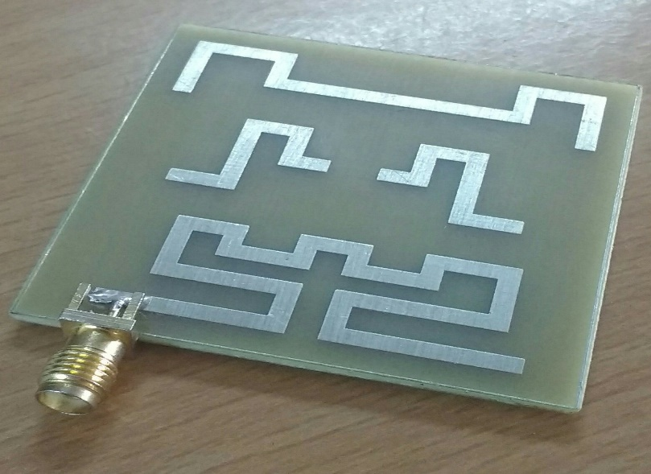

**Fig.3.1 Microstrip Patch Antenna.**

**3.7. CALIBRATION**

This method is mainly done in hardware to ensure that there is no error in the Network Analyzer to which the Microstrip antenna is connected through the feeding point. There are three different components in it they are,

* Load,
* Short,
* Open.

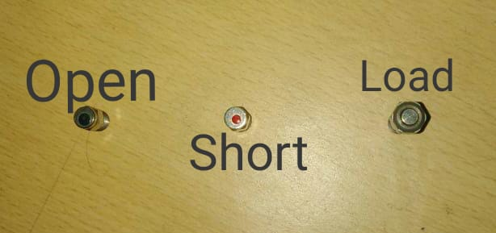

**Fig3.2 Types of Calibration**

**3.7.1 LOAD**

It is connected to feeding point of the network analyzer. The load is made of a small stainless-steel bullet like structure, which is 50 ohms in resistance. This is then virtually calibrated with a computer to which the network analyzer is connected.

**3.7.2 SHORT**

Same as Load, Short is another type of calibration connected to the feeding point of the network analyzer. It is also made up of stainless-steel. The resistivity of short is 0 (zero) ohms resistance because of its short circuit performance.

**3.7.3 OPEN**

Open is final calibration connected to the network analyzer. It has a resistance of infinite ohms resistance, because of its open circuit performance. It is also made up of stainless steel.

**3.8 ANTENNA**

The proposed antenna is made up of copper on a printed circuit board which has patches of 3 different kinds. The patches are named as EBG structured patch antenna. Which has 3 patches in the shape of ‘E’,’B’ and ‘G’. Higher the length of the patch lower the operating frequency of the patch antenna. The ‘E’ shape has large length of 161mm. The ‘B’ shape has the length of 39mm. The ‘G’ shape patch is of length is 82mm.

**3.9 WORKING AND ERROR CHECK**

Before working with human head model the antenna is checked for zero error and if the error is found the error is eliminated using bit error rate.

**3.10 SAM PHANTOM WITHOUT TUMOUR**

The human head without the tumour in it is used here for detection of the SAR value of the normal human cells or healthy human cells. Sam phantom is nothing but the human head model used in the CST software modelling method.

Here the antenna is placed at a distance of 60mm or 6 cm because the most effective radiance distance covered by it is at 60mm from the antenna. This helps the SAR calculation to have a maximum SAR point of 1.6W/kg or above which is widely required for the detection of Brain tumour in the human head.

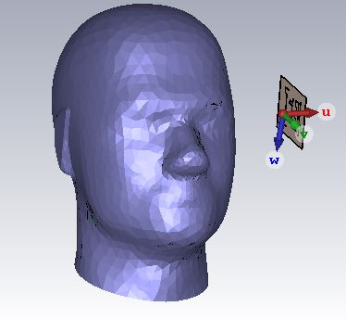

**Fig.3.3 SAM PHANTOM WITHOUT TUMOR**

**3.10.1. SAR REPORT**

After placing the antenna near the head of the healthy human we can start feeding the microstrip antenna. In CST software, we can start the stimulation process and finally the report is automatically generated by the CST software which can be viewed with the help of XPS viewer.

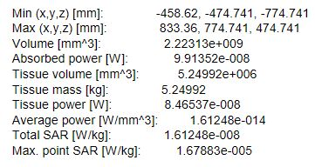

**Fig3.4 SAR REPORT WITHOUT TUMOUR**

**3.11 SAM PHANTOM WITH TUMOR**

The Sam Phantom is nothing but the human head model which may or many not contains tumour cells depending on the user requirement. Same as the head inserted in it that file even tumour can be inserted in it. The Specific absorption rate of the frequency of signals sent by the microstrip patch antenna is at very different rate compared to the specific absorption rate a healthy human’s brain cells. This is mainly because of the tumor cells which behave at different character at different time thus it has a very much difference in the specific absorption rate.

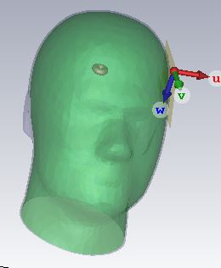

**Fig 3.5 SAM PHANTOM WITH TUMOUR**

**3.11.1. SAR REPORT**

Same as the report for Sam phantom without tumor is generated by the CST stimulation software itself is the SAR report of the for the Sam phantom with tumor. This report is generated as soon as we start the stimulation of the CST file where the microstrip antenna is placed at a distance of 60mm from the Sam phantom or the human head the antenna starts to radiate the signal which is absorbed by the Cancer cells at different ratio.

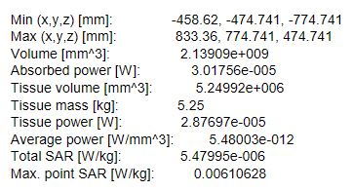

**Fig.3.6 SAR REPORT WITH TUMOR**